**Nuclear Test Image Gallery**

(Mirror of the web page originally hosted by Los Alamos National Laboratory)

These scientific images may be browsed at your leisure.

*Note*: The original GIF images have been converted to JPEG to reduce their size but maintain the same quality.

**Nuclear Weapons Tests:**

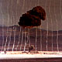

**Able**

1kt, Nevada Test Site, 27.Jan.1951 or 1.Apr.1952  
[(31k)](http://www.cddc.vt.edu/host/atomic/images/ableb.jpg)

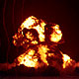

**Annie 1**

16kt, Nevada Test Site, 17.Mar.1953  
[(32k)](http://www.cddc.vt.edu/host/atomic/images/annie1b.jpg)

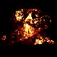

**Annie 2**

16kt, Nevada Test Site, 17.Mar.1953  
[(32k)](http://www.cddc.vt.edu/host/atomic/images/annie2b.jpg)

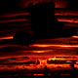

**Apache**

1.9Mt, Eniwetok, 8.Jul.1956  
[(38k)](http://www.cddc.vt.edu/host/atomic/images/apacheb.jpg)

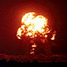

**Apple**

14kt, Nevada Test Site, 29.Mar.1955  
[(38k)](http://www.cddc.vt.edu/host/atomic/images/applb.jpg)

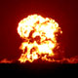

**Apple II**

29kt, Nevada Test Site, 5.May.1955  
[(29k)](http://www.cddc.vt.edu/host/atomic/images/appliib.jpg)

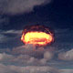

**Arkansas**

Low 1Mt, Christmas Island, 2.May.1962  
[(37k)](http://www.cddc.vt.edu/host/atomic/images/arkansb.jpg)

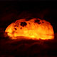

**Aztec**

20kt-1Mt, Christmas Island, 27.Apr.1962  
[(29k)](http://www.cddc.vt.edu/host/atomic/images/aztecb.jpg)

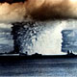

**Baker**

21kt, Bikini, 24.Jul.1946  
[(86k)](http://www.cddc.vt.edu/host/atomic/images/bakerb.jpg)

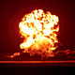

**Bee**

8kt, Nevada Test Site, 22.Mar.1955  
[(86k)](http://www.cddc.vt.edu/host/atomic/images/beeb.jpg)

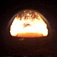

**Bighorn**

>1M, Christmas Island, 27.Jun.1962  
[(28k)](http://www.cddc.vt.edu/host/atomic/images/bighrnb.jpg)

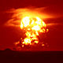

**Blackfoot**

8.5kt, Eniwetok, 11.Jun.1956  
[(17k)](http://www.cddc.vt.edu/host/atomic/images/blackftb.jpg)

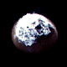

**Bluegill**

<1Mt, Johnston Island, 26.Oct.1962  
[(21k)](http://www.cddc.vt.edu/host/atomic/images/bluegllb.jpg)

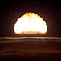

**Bluestone 1**

>1Mt, Christmas Island, 30.Jun.1962  
[(22k)](http://www.cddc.vt.edu/host/atomic/images/blustn1b.jpg)

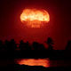

**Bluestone 2**

>1Mt, Christmas Island, 30.Jun.1962  
[(21k)](http://www.cddc.vt.edu/host/atomic/images/blustn2b.jpg)

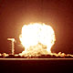

**Blotzman**

12kt, Nevada Test Site, 28.May.1957  
[(21k)](http://www.cddc.vt.edu/host/atomic/images/boltzmnb.jpg)

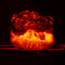

**Bravo**

15Mt, Bikini, 28.Feb.1954  
[(21k)](http://www.cddc.vt.edu/host/atomic/images/bravob.jpg)

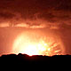

**Cactus**

18kt, Eniwetok, 5.May.1958  
[(21k)](http://www.cddc.vt.edu/host/atomic/images/cactusb.jpg)

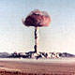

**C**

"Buster Charlie", 14kt, Nevada Test Site, 30.Oct.1951  
[(96k)](http://www.cddc.vt.edu/host/atomic/images/cb.jpg)

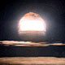

**Chama**

>1Mt, Johnston Island, 18.Oct.1962  
[(27k)](http://www.cddc.vt.edu/host/atomic/images/chamab.jpg)

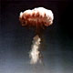

**Charlie 1**

14kt, Nevada Test Site, 30.Oct.1951  
[(25k)](http://www.cddc.vt.edu/host/atomic/images/charli1b.jpg)

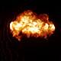

**Charlie 2**

31kt, Nevada Test Site, 22.Apr.1952  
[(25k)](http://www.cddc.vt.edu/host/atomic/images/charli2b.jpg)

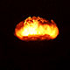

**Chetko**

20kt-1Mt, Christmas Island, 19.May.1962  
[(12k)](http://www.cddc.vt.edu/host/atomic/images/chetkob.jpg)

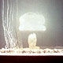

**Climax**

61kt, Nevada Test Site, 4.Jun.1953  
[(32k)](http://www.cddc.vt.edu/host/atomic/images/climaxb.jpg)

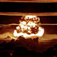

**Dakota**

1Mt, Bikini, 25.Jun.1956  
[(35k)](http://www.cddc.vt.edu/host/atomic/images/dakotab.jpg)

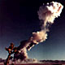

**D**

"Buster Dog," 21kt, Nevada Test Site, 1.Nov.1951  
[(35k)](http://www.cddc.vt.edu/host/atomic/images/db.jpg)

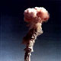

**Dog 1**

21kt, Nevada Test Site, 1.Nov.1951  
[(21k)](http://www.cddc.vt.edu/host/atomic/images/dog1b.jpg)

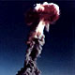

**Dog 2**

19kt, Nevada Test Site, 1.May.1951  
[(19k)](http://www.cddc.vt.edu/host/atomic/images/dog2b.jpg)

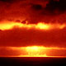

**Dog 3**

19kt, Nevada Test Site, 1.May.1951  
[(30k)](http://www.cddc.vt.edu/host/atomic/images/dog3b.jpg)

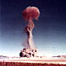

**E**

"Buster Easy," 31kt, Nevada Test Site, 5.Nov.1951  
[(43k)](http://www.cddc.vt.edu/host/atomic/images/eb.jpg)

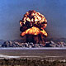

**Fizeau 1**

11kt, Nevada Test Site, 14.Sep.1957  
[(62k)](http://www.cddc.vt.edu/host/atomic/images/fizeau1b.jpg)

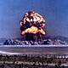

**Fizeau 2**

11kt, Nevada Test Site, 14.Sep.1957  
[(46k)](http://www.cddc.vt.edu/host/atomic/images/fizeau2b.jpg)

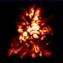

**Fox**

11kt, Nevada Test Site, 25.May.1952  
[(36k)](http://www.cddc.vt.edu/host/atomic/images/foxb.jpg)

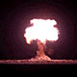

**Franklin**

4.7kt, Nevada Test Site, 30.Aug.1957  
[(14k)](http://www.cddc.vt.edu/host/atomic/images/franklnb.jpg)

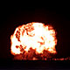

**Galileo**

11kt, Nevada Test Site, 2.Sep.1957  
[(25k)](http://www.cddc.vt.edu/host/atomic/images/galileob.jpg)

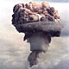

**George**

225kt, Nevada Test Site, 8.May, 1951  
[(41k)](http://www.cddc.vt.edu/host/atomic/images/george1b.jpg)

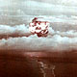

**George**

15kt, Nevada Test Site, 1.Jun.1952  
[(46k)](http://www.cddc.vt.edu/host/atomic/images/george2b.jpg)

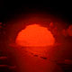

**Greenhouse**

??, Eniwetok, 1951  
[(46k)](http://www.cddc.vt.edu/host/atomic/images/ghouseb.jpg)

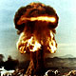

**Grable**

15kt, Nevada Test Site, 25.May.1953  
[(65k)](http://www.cddc.vt.edu/host/atomic/images/grableb.jpg)

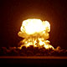

**Harry**

32kt, Nevada Test Site, 19.May.1953  
[(14k)](http://www.cddc.vt.edu/host/atomic/images/harryb.jpg)

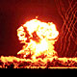

**Hornet**

4kt, Nevada Test Site, 12.Mar.1955  
[(43k)](http://www.cddc.vt.edu/host/atomic/images/hornetb.jpg)

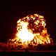

**How**

14kt, Nevada Test Site, 5.Jun.1952  
[(24k)](http://www.cddc.vt.edu/host/atomic/images/howb.jpg)

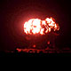

**Kepler**

10kt, Nevada Test Site, 24.Jul.1957  
[(13k)](http://www.cddc.vt.edu/host/atomic/images/keplerb.jpg)

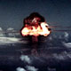

**King**

500kt, Eniwetok, 15.Nov.1952  
[(33k)](http://www.cddc.vt.edu/host/atomic/images/kingb.jpg)

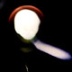

**Kingfish**

<1Mt, Johnston Island, 1.Nov.1962  
[(26k)](http://www.cddc.vt.edu/host/atomic/images/kingfshb.jpg)

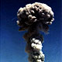

**Met**

22kt, Nevada Test Site, 15.Apr.1955  
[(37k)](http://www.cddc.vt.edu/host/atomic/images/metb.jpg)

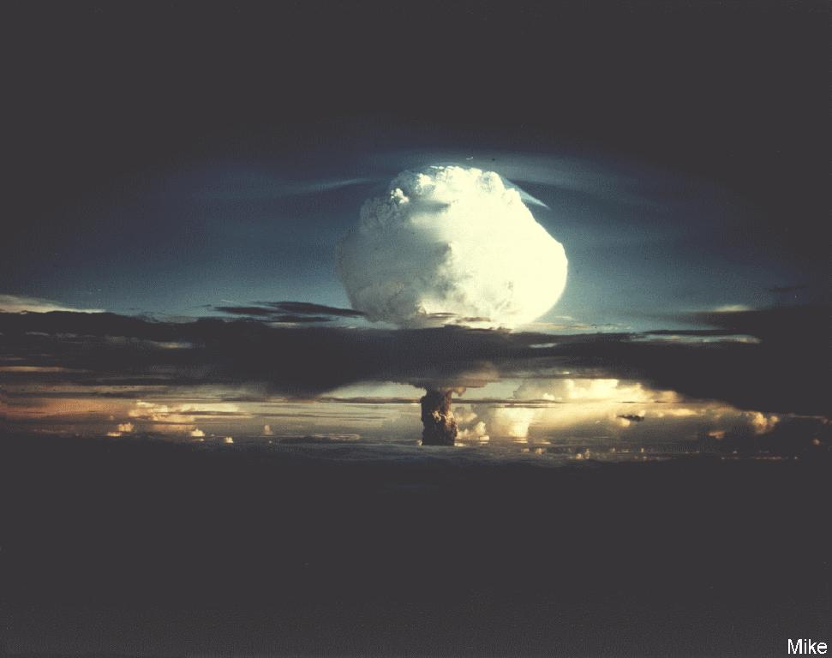

**Mike**

10.4Mt, Eniwetok, 31.Oct.1952  
[(38k)](http://www.cddc.vt.edu/host/atomic/images/mike1b.jpg)

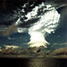

**Mike**

10.4Mt, Eniwetok, 31.Oct.1952  
[(42k)](http://www.cddc.vt.edu/host/atomic/images/mike2b.jpg)

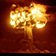

**Mohawk**

350kt, Eniwetok, 2.Jul.1956  
[(38k)](http://www.cddc.vt.edu/host/atomic/images/mohawkb.jpg)

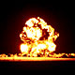

**Moth**

2kt, Nevada Test Site, 22.Feb.1955  
[(25k)](http://www.cddc.vt.edu/host/atomic/images/mothb.jpg)

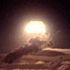

**Nambe**

20kt-1Mt, Christmas Island, 27.May.1962  
[(19k)](http://www.cddc.vt.edu/host/atomic/images/nambeb.jpg)

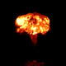

**Newton**

12kt, Nevada Test Site, 16.Sep.1957  
[(12k)](http://www.cddc.vt.edu/host/atomic/images/newtonb.jpg)

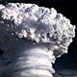

**Oak**

8.9Mt, Eniwetok, 28.Jun.1958  
[(67k)](http://www.cddc.vt.edu/host/atomic/images/oakb.jpg)

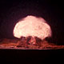

**Santa Fe**

1.3kt, Nevada Test Site, 30.Oct.1958  
[(9k)](http://www.cddc.vt.edu/host/atomic/images/santafeb.jpg)

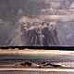

**Seminole**

13.7kt, Eniwetok, 6.Jun.1956  
[(73k)](http://www.cddc.vt.edu/host/atomic/images/seminolb.jpg)

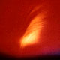

**Starfish 1**

1.4Mt, Johnston Island, 9.Jul.1962  
[(22k)](http://www.cddc.vt.edu/host/atomic/images/sfish1b.jpg)

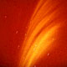

**Starfish 2**

1.4Mt, Johnston Island, 9.Jul.1962  
[(17k)](http://www.cddc.vt.edu/host/atomic/images/sfish2b.jpg)

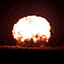

**Shasta**

17kt, Nevada Test Site, 18.Aug.1957  
[(15k)](http://www.cddc.vt.edu/host/atomic/images/shastab.jpg)

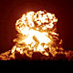

**Simon**

17kt, Nevada Test Site, 18.Aug.1957  
[(28k)](http://www.cddc.vt.edu/host/atomic/images/simonb.jpg)

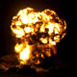

**Smokey**

44kt, Nevada Test Site, 31.Aug.1957  
[(42k)](http://www.cddc.vt.edu/host/atomic/images/smokeyb.jpg)

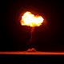

**Socorro**

6kt, Nevada Test Site, 22.Oct.1958  
[(16k)](http://www.cddc.vt.edu/host/atomic/images/socorrob.jpg)

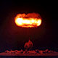

**Stokes**

19kt, Nevada Test Site, 7.Aug.1957  
[(16k)](http://www.cddc.vt.edu/host/atomic/images/stokesb.jpg)

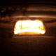

**Sunset**

20kt-1Mt, Christmas Island, 10.Jul.1962  
[(20k)](http://www.cddc.vt.edu/host/atomic/images/sunsetb.jpg)

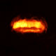

**Swanee**

20kt-1Mt, Christmas Island, 14.May.1962  
[(17k)](http://www.cddc.vt.edu/host/atomic/images/swaneeb.jpg)

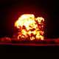

**Tesla**

7kt, Nevada Test Site, 1.Mar.1955  
[(19k)](http://www.cddc.vt.edu/host/atomic/images/teslab.jpg)

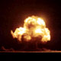

**Trinity**

21kt, New Mexico, 16.Jul.1945  
[(21k)](http://www.cddc.vt.edu/host/atomic/images/trinit1b.jpg)

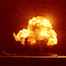

**Trinity**

21kt, New Mexico, 16.Jul.1945  
[(33k)](http://www.cddc.vt.edu/host/atomic/images/trinit2b.jpg)

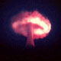

**Truckee**

20kt-1Mt, Christmas Island, 9.Jun.1962  
[(16k)](http://www.cddc.vt.edu/host/atomic/images/truckeeb.jpg)

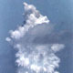

**Umbrella**

9kt, Eniwetok, 8.Jun.1958  
[(34k)](http://www.cddc.vt.edu/host/atomic/images/umbrelb.jpg)

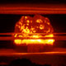

**Union**

6.9Mt, Bikini, 25.Apr.1954  
[(26k)](http://www.cddc.vt.edu/host/atomic/images/unionb.jpg)

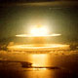

**Yeso**

>1Mt, Christmas Island, 10.Jun.1962  
[(29k)](http://www.cddc.vt.edu/host/atomic/images/yeso1b.jpg)

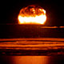

**Yeso**

>1Mt, Christmas Island, 10.Jun.1962  
[(22k)](http://www.cddc.vt.edu/host/atomic/images/yeso2b.jpg)

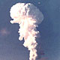

**Yukon**

20kt-1Mt, Christmas Island, 8.May.1962  
[(46k)](http://www.cddc.vt.edu/host/atomic/images/yukonb.jpg)